Peer-Reviewed Assessment
Peer Reviewer: Vani Kannan
Date: 2023
License: CC BY-NC 4.0

Exploring the Archives
Archival Research Assignment

Laura Clarke
laurahelenclarke@gmail.com

This semester, we have been thinking about the question of whose voices shape knowledge and whose voices are left out, and how this is reflected in what is documented in the archives. In her introduction to Wayward Lives, Beautiful Experiments, Saidiya Hartman warns that “Every historian of the multitude, the dispossessed, the subaltern, and the enslaved is forced to grapple with the power and authority of the archive and the limits it sets on what can be known, whose perspective matters, and who is endowed with the gravity and authority of historical actor” (Hartman xiii). As “historian[s] of the multitude,” you will explore the various nineteenth-century digital archives at the New York Public Library (NYPL). Keeping in mind Hartman’s words, you will look for and analyze a primary source that tells us something about people who have been left out of history (as we saw in the Black Chronicles II exhibition), or a primary source that encodes a position of power and/or places limits on what can be known (as we saw in colonial advertising). If you have not already, you will need to sign up for a digital library card.

Key Terms:

An archival collection is created by or for a person, family, group, or subject, and an archive is the place in which these materials are preserved for the purposes of historical, informational, legal, or evidential record. Researchers can locate many unique primary and secondary materials in archival collections. For instance, many archives preserve and make accessible diaries, letters, photographs, newspapers, pamphlets, and other primary source documents. Many of the documents and images we have studied this semester were retrieved from digital archives.

A digital archive is similar in purpose to a physical archive, but the historical documents and objects that provide evidence of the past have been digitized (often by scanning or photography, unless a document was created digitally in the first place) and made available online. Digitized objects (e.g., a digitized print photograph, or a digitized print news article) are called surrogates because technically they are not the original items but substitutes.

You will conduct your own research using digital archives available online through the NYPL. The archival databases listed below are just a few of the available options; you are welcome to choose a different database accessible through the NYPL. You can also contact a Guttman librarian (library@guttman.cuny.edu) for help locating or searching digital collections.

- Nineteenth Century Collections Online (also available through the Guttman Library website)
- American Underworld: The Flash Press – Crime, Scandal, and Blackmail Papers of the Nineteenth Century
- African American Newspapers: The 19th Century
- 19th Century British Newspapers
- 19th Century UK Periodical Series I & II

After spending some time exploring the archives, you will choose one primary source to analyze. This could be a photograph, a stereograph, a carte-de-visit album, a newspaper article, a pamphlet, a cartoon, a playbill, a literary work, or something else. You will write a 3-page analysis of your chosen primary source and submit your work on the learning management system.

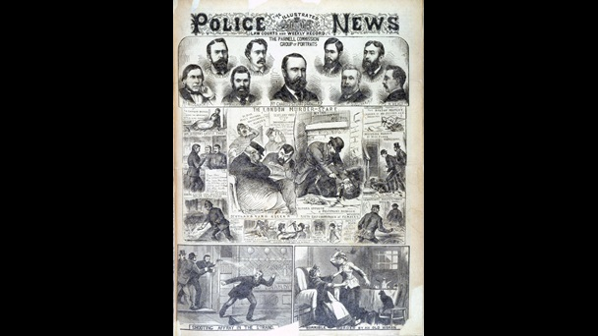

“The London Murder Scare.” 3 November 1888. Discovering Literature: Romantics and Victorians. 1888 LON 121A [1888] NPL. The British Library.

Analyzing a Primary Source

A primary source provides first-hand testimony or direct evidence concerning a topic. Primary sources are created by individuals responding to their historical and social situation or surroundings. We have analyzed many primary sources this semester such as works of art, newspaper articles and political cartoons, personal letters, and scientific texts.

I will be assessing your work based on your satisfactory completion of the following steps that we have been practicing over the semester. You will follow these steps to complete a first draft and then revise your work based on my feedback.

1. Identify the Source
Who created it? Can you find any information about the creator? When and where was it created? Where was it published? Who was it created for?

2. Place the Source in Context
As we have seen over the semester, writers or artists respond to their situation or surroundings. Using what we have discovered about the nineteenth century over the semester, what is the historical and social situation surrounding your primary source?

3. Analyze the Source Content
Once you can place the source in its original context, you can start analyzing the source. What crucial elements or details do you see in that source?

4. Assess the Source Perspective
What in the source tells us about the creator’s perspective on the subject? Can you detect any ideology or bias? Is the creator attempting to persuade or convince their audience to believe or do something?

5. Making Connections
Finally, make connections between your primary source and other themes and issues we have discussed this semester.

Exploring the Archive Essay Requirements:
- 3-page essay that describes and analyzes an archival source
- A citation for your chosen source. The citation you use will depend on the type of primary source you choose. For information on how to cite different archival sources, see https://libguides.csudh.edu/archives-citation/mla.

