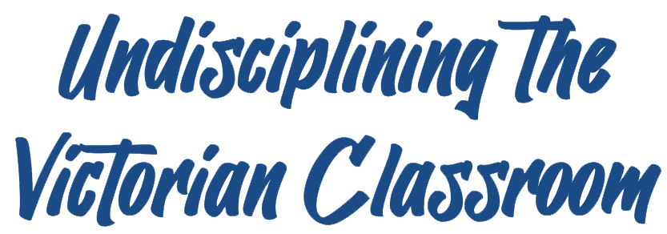
Peer-Reviewed Assessment
Peer Reviewer: Sarah Ohmer
Date: 2023
License: CC BY-NC 4.0

(Post-)Colonial Biography

Undisciplining the Victorian Classroom
Dr. Amanda Shubert, UW-Madison

How does the history of British and U.S. imperialism that we are learning about this semester connect with your life? With who you are as a person? With the lives and experiences of those you love? This is a short personal essay that asks you to research your own life! The goal is for us, as a class, to learn how the history of empire continues to influence us today in myriad ways both big and small. By choosing one of the following prompts, creating a written or video essay, and sharing your work in a small group, you will discover how you and your classmates are part of the global history of empire and colonialism and reflect on what this means to you.

Prompts.

- Conduct an interview with someone you love who is from the former British Empire or the current British Commonwealth and report on what you learn. This can be a family member or a friend—it just has to be someone you care about. Your project must include a short biography of this person focused on their connection to their country of origin, and a discussion of how this person’s life was impacted by former or current British influence. Prepare for your interview by researching the history of British colonialism in this person’s country of origin so that you can create effective questions. Topics you might want to discuss include: Did this person live through a process of decolonization or in the aftermath of decolonization, and what do they remember? What markers of British-ness or British presence do they recall from their lives in that country? (Think: languages spoken, foods, school curriculum, framed photos of the Queen or Royal Family in public places.) Your project must include:
  - A biography of this person, beginning with who they are and why they matter to you. The biography should be focused on their connection to their home country.
  - A discussion of at least one way that their lives were/are shaped by the history of the British Empire.
  - Incorporation of at least two secondary sources that you consulted to learn about the colonial history of your interviewee’s home country.

- Describe how your home country was/is impacted by the history of British Empire and how you think this affects your life today. This prompt is open to all students who grew up in a former British colony or a country affected by British imperialism, including Canada, the U.S., China, Hong Kong, Taiwan, India, Pakistan, Bangladesh, much of the Caribbean, and more. Your project should provide a brief history of what British imperialism looked like in your country and should identify at least one way that British control in your country continues to shape your life. Connections might include the language(s) you grew up speaking or learning, foods you grew up eating, major industries in your home country, or a family connection to the Transatlantic Slave Trade (enslaved ancestors, ancestors who owned enslaved people). Your project must include:
  - Historical context: when and where you were born, dates of British presence and/or imperial control in your country of origin, and an explanation of the type of imperialism your country experienced (e.g., settler colonialism, extractive colonialism, occupation, etc.).
  - A concrete example of how British imperialism in your country shapes your life.
  - Incorporation of at least two secondary sources that you consulted to learn about the imperial history of your home country and/or the connection between British Empire and your life.

- Research your own participation in U.S. settler colonial history as a student at UW-Madison. Those of us who live and work in Madison, WI occupy the ancestral home of the Ho-Chunk people, who were forced to cede this land to the U.S. in an 1832 treaty and subjected to decades of ethnic cleansing. Ho-Chunk people still live in Madison today but are denied sovereignty of their own land. Choose a specific topic to research, such as: how the 1832 treaty paved the way for the establishment of the University of Wisconsin in Madison; a sacred Ho-Chunk site on or around campus, like Bascom Hill; or the history of a late-nineteenth-/early-twentieth-century Native American boarding school in Wisconsin. Your project must include:
  - A discussion of the history of the topic you chose.
  - A reflection on how this history connects to your life as a UW-Madison student.
  - Incorporation of at least two secondary sources that you consulted to learn about your topic.

- Research and write the colonial history of a commodity, place, or work of art. The key here is that it is something you care about and that plays an important role in your life—something that you might even consider part of your identity. For commodities, think tea, coffee, or chocolate; for places, think of a favorite vacation to London or Jamaica; for art, an album like Rihanna’s Anti; or something else entirely, as long as you can explain its connection to the history of the British Empire. For example, if you are a Rihanna fan, you might want to learn about the colonial history of her home country (Barbados) and how it influences her music. If you are a daily tea-drinker, learn where (and how) British and American people got their tea in the nineteenth century and where your tea comes from today. If you loved visiting stately homes in London, learn about the former owners of one of those homes and how their wealth came from overseas colonies and/or the Atlantic Slave Trade. Your project must include:
  - A description of this object of your affection, starting with the role it plays in your life and why it matters to you.
  - A history of how it is connected to the history of British Empire.
  - Incorporation of at least two secondary sources that you consulted to learn about the colonial history of your topic.

Format.

You have two options. You may submit this project as a 3-5-page, double-spaced, 12-point font essay (uploaded to the learning management system) or a 5-7-minute video recording (uploaded to YouTube as an unlisted video and submitted on the learning management system as a link). You are welcome, but not required, to include photographs or other illustrations. Note that if you submit your essay in written form, illustrations do not count as part of the total length.

Audience.

You will be placed in a group of four and assigned to read/watch and comment on each other’s projects. Remember that you are writing/speaking to your peers and you are responsible for teaching them what you have learned. This means your work should be typo- and glitch-free, proof-read, and clearly and engagingly explained or presented.

