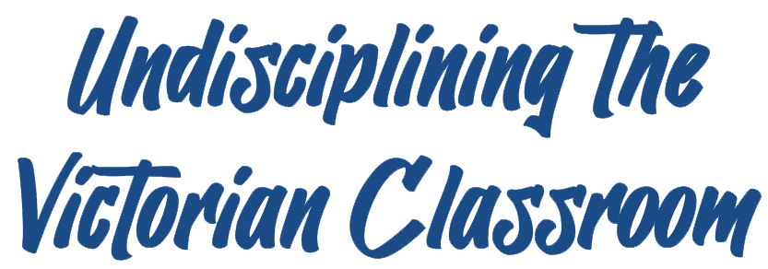
Peer-Reviewed Assignment
Peer Reviewer: Jacqueline Barrios
Date: 2025
License: CC BY-NC 4.0

Narrating Victorian Poetry

Ashley Nadeau
Utah Valley University
ANadeau@uvu.edu

Assignment Overview:
For this assignment, you’ll take a page out of our audiobook texts and create your own recorded narration of a Victorian literary work. You will choose a poem from our Victorian poetry module (on our course webpage and in our COVE anthology) or from COVE’s “Works by and about People of Color” to study and recite. Your study of this poem should include both research into its historical and critical context and repeated readings to deepen your understanding and appreciation of the text. Once you’ve familiarized yourself with the poem’s contexts and decided on the style and tone of your narration, you will record your recitation and post it as an audio file annotation to our shared COVE anthology. Alongside your recitation, you will compose a 5-6-page narrator’s statement that addresses the choices you made in your recitation and what you learned through your research and in your efforts to learn and recite the poem. Your statement should also address how completing this project impacted your understanding and appreciation of the poem.

Instructions:
- During Week 4, review and select a poem from those included in the “Victorian Poetry” module on our course webpage or in COVE’s “Works by and about People of Color.” If you would like to select a Victorian poem not included in either list, please submit a brief proposal identifying the poem you’d like to study and your reasons for selecting this poem.
- Once you’ve selected your poem, begin researching the poem’s author, the historical and publication context of the poem, and how the poem has been received and interpreted by literary critics and the public since it was published. Be sure to use the academic resources of the UVU Fulton Library and privilege peer-reviewed, academic, or otherwise credible sources (for example, museum and library sites). Your research should include 3-6 sources from a variety of publications/platforms.
- Read, study, and practice your chosen poem. Consider how your research informs the tone and style of your recitation. Reflect on the narratorial choices our audiobooks’ narrators have been making and explore how a shift in emphasis, emotion, and cadence changes the feel of the poem. Imagine potential audiences (past and present) for the poem and for your recitation. Think about how your immediate audience (our class) shapes your performance.
- Record yourself reciting your poem with your phone or computer. Play around with different recording locations (like a large vs. small room, your car, or a closet) and tools/software and pay attention to sound quality and the clarity of your recitation. Re-record until you have a version that you like and that sounds polished and (relatively!) professional.
- Compose a 5-6-page companion essay that serves as a narrator’s statement and reflection on your research and recitation. Your essay should provide a brief overview of the poem’s author and historical and critical context, a detailed explanation of the stylistic choices you made as the poem’s narrator, and a thoughtful examination of how this process has shaped your intellectual and aesthetic assessment of the poem. It should conclude with a brief critical assessment of the poem and its relevance to readers today.

