Peer-Reviewed Syllabus
Peer Reviewer: Elaine Freedgood
Date: 2021
License: CC BY-NC 4.0

Priyanka Anne Jacob
Loyola University Chicago
pjacob@luc.edu

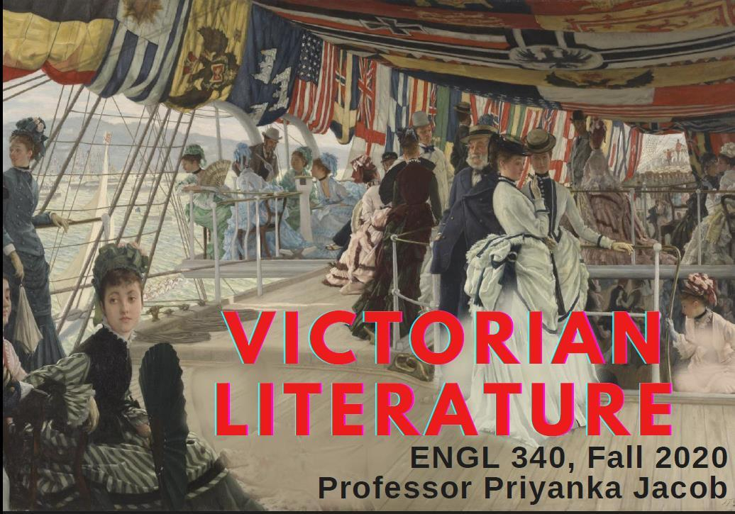
In this online introduction to Victorian literature and culture, we will investigate how Victorian culture produced and contested ideologies of class, race, gender, empire, and labor that continue to shape our world today. We’ll encounter an array of works, including industrial novels, activist poetry, memoir and travelogues, social media videos, early photography, and archival documents. We will bring our analysis of the nineteenth century into the present day, engaging with contemporary culture and discussing how we continue to grapple with the legacies of the Victorians.

Schedule of Readings

Week 1: What is Victorian? What is British?
What associations, values, and implications do these words carry today? Who is invoked by these terms and who is excluded? How do we want to relate to these concepts?
- Danny Boyle, 2012 Olympics Opening Ceremony
- Akala, “The Propaganda of ‘British Values’ is a Distortion of History”

Week 2: Mary Barton, Hunger & Exploitation
This week we will begin reading Elizabeth Gaskell's “industrial novel” Mary Barton. We will situate the history of the Industrial Revolution in a global system that included chattel slavery, child labor, and imperial exploitation. We will also learn about the “Hungry Forties” and urbanization, and we will attend to how the novel plants the seeds of social unrest. Watching contemporary folk trio The Hayes Sisters on YouTube will bring Margaret’s vocal performance from the novel alive for us.
- Elizabeth Gaskell, Mary Barton
- Friedrich Engels, “The Great Towns”
- Elizabeth Barrett Browning, “The Cry of the Children”
- The Hayes Sisters, “Four-Loom Weaver”

Week 3: Mary Barton & Sex Work
This week we will continue reading Mary Barton and situate the character of Esther within Victorian conversations about sex work. We will be led in this discussion by the voice of an anonymous nineteenth-century sex worker who explicitly revises the cultural trope of the “fallen woman.” We will collectively annotate the DGR poem “Jenny,” discussing whether it is possible to locate Jenny herself, behind and beyond the speaker’s conceits.
- Elizabeth Gaskell, Mary Barton
- Dante Gabriel Rossetti, “Jenny”
- Anonymous, “The Great Social Evil”

Week 4: Mary Barton, Political Power & “A Dying Wage”
This week we will continue reading Gaskell's novel and contextualize it with a documentary about the Chartists’ movement and the nineteenth-century push to expand political power. We will read articles by working-class activists and journalists pushing for reform, paying special attention to the clarity of labor activist Chew’s political and economic critique, as well as the rhetorical power and contemporary relevance of her lament that “ours is a lingering, dying wage.”
- Elizabeth Gaskell, Mary Barton
- Documentary on the Chartists
- Annie Besant, “White Slavery in London”
- Ada Chew, “A Living Wage”

Week 5: Mary Barton Conclusions
This week we will conclude the novel and analyze Gaskell’s choice to build a “new world” for her protagonists and displace the resolution of her industrial-problem novel onto the unceded land of the First Nations. What does this conclusion reveal about the entanglement of industrialism, racial capitalism, and imperial and ecological violence?
- Elizabeth Gaskell, Mary Barton

Week 6: Britain’s Legacy of Chattel Slavery
This week we will dive deeper into Britain's role in the enslavement and trafficking of African people during the three hundred years prior to Victoria's reign—and its later involvement in the abolitionist movement in mid-nineteenth-century United States. We will also read an abolitionist poem by Elizabeth Barrett Browning, whose own family wealth derived from chattel slavery. We will analyze this dramatic monologue, written in the voice of a woman who escaped from slavery in the American South, and discuss the possibilities and limits of the poem as an aesthetic and ethical exercise.
- Catherine Hall, “Britain’s Legacy of Slavery”
- Elizabeth Barrett Browning, “The Runaway Slave at Pilgrims Point”
- Excerpts from Timeline documentary on Britain’s slave trade

Week 7: Black Victorians & Black Lives Matter
This week we will explore the history of Black Britons through early photography from the nineteenth century. The Missing Chapter: Black Chronicles project provides a beautiful visual exploration of the lives and images of Black people in Britain in the nineteenth and early twentieth centuries, and Caroline Bressey’s scholarship will contextualize this project for us. In the second half of the week, we will explore how the British are reckoning with their own national identity and history in the summer of Black Lives Matter.

- Caroline Bressey, “Of Africa’s Brightest Ornaments: A Short Biography of Sarah Bonetta Forbes”
- Renée Mussai and Mark Sealy, The Missing Chapter: Black Chronicles Digital Gallery
- “Black Chronicles with Caroline Bressey” interview on Vimeo
- Social media clips of Colston statue toppling
- Nora McGreevey, “British Protesters Throw Statue of Slave Trader into Bristol Harbor”
- Roger Ball, “Myths Within Myths: Edward Colston and That Statue”
- Tristan Cork and Ellie Pipe, “Restoring Colston's Statue—Graffiti, Bike Tyre, and All”
- Laura Cripps, “Glasgow's Slave Trade Past Is All Around Us”
- Frankie Boyle, clip from Tour of Scotland

Week 8: Imperial Products, Imperial Gazes
This week we will focus on Britain’s accelerated imperial presence in the second half of the nineteenth century. We will also learn about how the British represented their imperial project to themselves, how they incorporated empire into their advertising, and how they brought the colonies “home” through the display of goods, resources, and even incarcerated people at the Indian and Colonial Exhibition. Additionally, we will read T. N. Mukharji’s travelogue and examine how he responded to and reversed the othering gaze placed on him when in London.
- Emma Hurley (@eamonndevalera), TikTok on British invasions
- Alfred, Lord Tennyson, “Opening of the Indian and Colonial Exhibition by the Queen, 1886”
- T. N. Mukharji, excerpt from A Visit to Europe
- Catalogue for the 1886 Indian & Colonial Exhibition
- Pear’s Soap ad
- Rudyard Kipling, “The White Man’s Burden”
- Ernest Crosby, “The Real White Man’s Burden”
- H. T. Johnson, “The Black Man’s Burden”

Week 9: Women: in the House, in the Garden, on the Battlefield
This week we will explore art and writing that conveyed ideologies around femininity and domesticity, often known by shorthand as “The Angel in the House,” after a poem of the same name by Coventry Patmore. We will see how Florence Nightingale was depicted in that vein, despite the very different story told by her work, writing, and personality. We will transition from Nightingale to our unit on Mary Seacole, thinking through both women’s medical and professional innovations and their different representations and legacies.
- Coventry Patmore, “The Angel in the House”
- John Ruskin “Of Queen’s Gardens”
- Slideshow of Victorian painting and photography on domesticity
- Florence Nightingale, excerpts from Cassandra
- Kathryn Hughes, “How Victorian Artists Saw Florence Nightingale”
- National Army Museum, “Florence Nightingale: The Lady with the Lamp”

Week 10–12: Mary Seacole, Global Victorians & Annotating a Digital Edition
We will spend three weeks in a cross-institutional project of reading and annotating a digital edition of Mary Seacole's memoir. Seacole, a “doctress” who has been recovered recently as an important figure in Black British history, will bring many of our previous themes into one text, as she travels the world describing numerous cross-cultural and cross-racial encounters. We will also examine how notions of femininity and respectability figure into her story of tending to cholera victims in Panama and to wounded soldiers in the Crimean War.
- Mary Seacole, The Wonderful Adventures of Mrs. Seacole in Many Lands
- Nicole Fluhr, “‘Their Calling me “Mother” Was Not, I Think, Altogether Unmeaning’: Mary Seacole’s Maternal Personae”
- Reading the annotations of your collaborators

Week 13: Victorian Christmas
It’s the holiday season. This week we will read Dickens's most enduring work, consider the possibilities and limits of its social message, and explore its afterlife in film and television.
- Charles Dickens, A Christmas Carol
- Michael Slater, “The Origins of A Christmas Carol”
- A. O. Scott, “Critic’s Pick: A Christmas Carol”
- Student’s choice: Film or television adaptation of A Christmas Carol

Week 14: Reimagining Victorian, Reimagining Britishness
This week we will conclude our course. We will take stock of how our understanding of the Victorians has changed, trace the through-lines from the nineteenth century to now, and discuss how we might reimagine Britishness for the future.
- Virginia Woolf, excerpts from Orlando
- Laurie Penny, “Tea, Biscuits & Empire: The Long Con of Britishness”

SAMPLE ASSIGNMENTS

Reading the Photographic Archive
Write an image analysis of at least two images from The Missing Chapter: Black Chronicles. You can choose any images you like (but if they are also images written about or discussed by Bressey, try not to simply repeat her analysis.) Your analysis should be attentive to the visual details present in each photograph. It can handle each photograph separately or put the two images into conversation. Your analysis should engage with many of the below questions, over the course of 2–3 substantial paragraphs:

- Examine the clothing, accessories, body language, and facial expressions of the sitter (the person posing for the picture). Look also at the setting and props used in the photograph. What do these details indicate? What messages do they send? What kind of persona is conveyed by these details?
- What additional information about the sitter (beyond the facts on the back) can you glean from the photograph? Can you draw conclusions about the sitter’s class, gender, profession, state of mind, emotion, or anything else?
- What questions do you have about the sitter? How does the photograph prompt your imagination?
- How does this photograph shape your understanding of British history and culture?
- Is there much information provided by the archive about your photograph? Why or why not? How is the metadata or information available about the photograph reflective of the institutions and power dynamics that structure how we tell history?

It is not as important how many of the questions get addressed as it is that your reflection be thoughtful and in-depth. The goal is to seriously explore, learn from, and perhaps even be moved by this glimpse into the photographic archive of Black and brown folks in Britain.

Sample Weekly Reflection Questions
- In her lecture, historian Catherine Hall shares that The History of Mary Prince was a narrative told by formerly enslaved woman, Mary Prince, to white English people who edited it and shaped it for publication—in other words, who mediate her story. Hall states that this text therefore gives “Some access to the experience of the enslaved woman, but only some.”

How would you apply Hall’s point about mediation and limited access to EBB’s poem, which imagines a fugitive from slavery as its speaker? Can this poem communicate any authentic experience of enslavement? If so, where and how? If not, what else can the poem do? How else might you frame the fictional speaker, and how else might we understand the poem’s purpose and effects? Be as specific as possible in your response.

- What did you notice when watching the London Olympics Opening Ceremony? How does Britain imagine its history? What sensory elements and production techniques are used to tell this story? How does this show represent labor, nature, national identities and boundaries, or class, race, and gender? What do you think this show is trying to say about Britishness?

- How would you describe author and hip-hop artist’s Akala intervention in defining Britishness and British values? (Note that Akala explains he is “not a nationalist” but nevertheless believes it’s important to understand how national identities are formed and what they mean.) What is his critique of “the propaganda of British values”? What is the story of British values that he tells instead?

- Laurie Penny argues that “Every nation-state is ninety percent fictional; there’s always a gap between the imaginary countries united by cultural coherence and collective destinies where most of us believe we live, and the actual countries where we’re born and eat breakfast and file taxes and die. The U.K. is unique among modern states in that we not only buy our own hype, we also sell it overseas at a markup.” Penny’s article illustrates many such gaps between the “imaginary country” and the actual one, between the popular narrative of Britishness and its realities and histories. In your reflection, analyze at least two of the gaps Penny mentioned. What stories are told, and what do they leave out? What assumptions, values, or messages do these stories carry? What counter-narratives does Penny suggest might exist? Be specific, grounding your response in evidence from Penny’s article.

Sample Final Essay Prompt
Home in the World: Many Victorian texts are interested in the concept of home—what it should look and feel like, what endangers it, what/whom it keeps in and out. At the same time, the Victorians were expanding their presence abroad through an ever-growing empire—making themselves “at home” all over the world and spreading a sense of homey Britishness beyond their isles. How do the texts from our syllabus represent “home” in the global, imperial nineteenth century? In the texts we’ve read, how do imperial subjects relate to Britain and to their places of origin? How do the British relate to their colonies? How are the values, promises, and fantasies of home reinforced, broken down, or exported through the extension of Britain’s global reach? For this essay, make an argument about the representation of home and empire in 2–3 texts from the syllabus.

Seacole Collective Annotation Assignment
In collaboration with a class at another institution, we will use the online tool COVE Studio to collectively annotate the memoir, The Wonderful Adventures of Mary Seacole in Many Lands by Mary Seacole, over the next three weeks. The assignment consists of writing 2 annotations on specific passages in the text and writing a reflection essay on the experience.

Your annotations should: make an interpretive claim about the passage or phrase; ground that claim in textual evidence; engage with Seacole’s specific language; be clearly and coherently written. They may also include personal reactions and reflections to the text; reflect on cultural and historical questions raised by Seacole’s text; and pull in outside sources as long as they are academic in nature (COVE has the capacity to include images and links within annotations).

Your reflection essay should demonstrate that you have read and engaged with your colleagues’ annotations, and it should refer specifically to at least two annotations that other people wrote. It should address the following questions: How do you read Seacole differently this week in light of your colleagues’ annotations? What have you learned about Seacole’s use of language and literary form or her navigation of complex cultural contexts that didn’t come up in class or when you were reading on your own? The reflection might also comment on how the online annotation experience changed the reading experience and the status of the text or how collective annotation might function as a kind of social media, facilitating social reading. While readers connect to the text, are connections also created among readers?

