Peer-Reviewed Syllabus
Peer Reviewer: Charles LaPorte
Date: 2024
License: CC BY-NC 4.0

Religion and the Transimperial: Literatures of Faith, Conquest, and Resistance

Padma Rangarajan
padma.rangarajan@ucr.edu

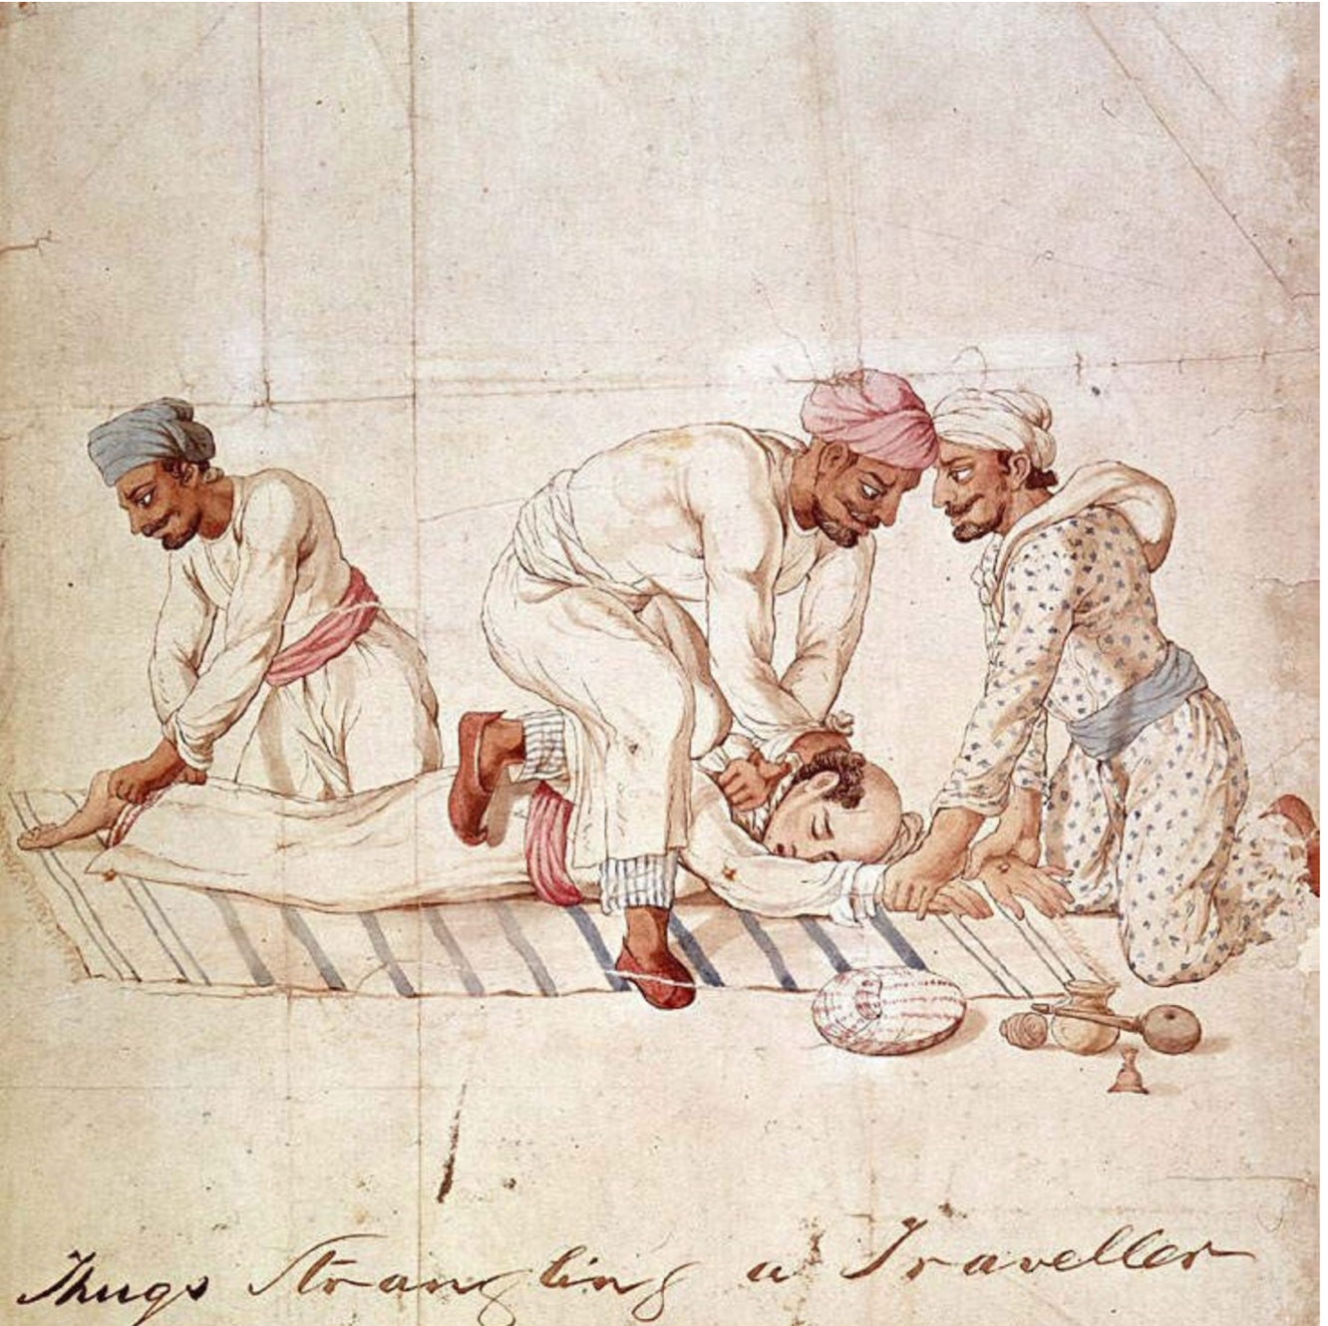

Anonymous Indian artist. A group of Thugs strangling a traveller on a highway in India in the early 19th century. One member of the group is gripping the traveller’s feet, another his hands, while a third member is tightening the ligature around the traveller’s neck. 1829–40, https://en.m.wikipedia.org/wiki/File:Thugs_Strangling_Traveller.jpg.

Course Description

What happens when different religious traditions meet each other in asymmetrical relations of power? How is religion used to justify, protest, and conceptualize colonial conquest? What is the relationship between religious faith and modernity? Late-nineteenth-century literature grapples with these questions. The nineteenth century has generally been associated with a triumphal imperialism and with the erosion of religious faith in the face of an irresistible move toward the secular. In contrast, this course argues that colonial contact led to the sharing and fusing of different religious concepts and ideologies and explores how this fusion was represented in the literature of Britain and its most important imperial holding, India. We’ll examine how imperial expansion and societal change enabled diverse and new expressions of faith and spirituality. We’ll also consider how religion was a powerful, if unstable, tool for both colonial conquest and anticolonial resistance. Crucially, we will explore how different genres of literature responded to and were shaped by this discourse of religion and empire. We’ll consider how and why certain genres, like the oriental tale, were overtaken by the realist novel, and we will study how Indian authors mingled European poetic forms with native ones. Although the class focuses primarily on India, we will also consider literary representations of Africa and the Middle East as important points of comparison.

Course Assignments

Biweekly reading responses
Final Project: 6-8 page paper plus collaborative concept map

Required Texts

Eliot, Adam Bede
Haggard, She
Course Reader

Syllabus

Week 1

Locating the Divine

Tu Introduction, Hopkins, “God’s Grandeur”; Dutt, “The Tree of Life”
Th Rossetti, “A Better Resurrection”; Kipling, “Recessional”; Vivekananda, “Kali the Mother”

Week 2

Realism and Religion

Tu Eliot, Adam Bede
Th Eliot, Adam Bede

Week 3

Tu Eliot, Adam Bede
Th Eliot, Adam Bede

Week 4

Empire and the Occult

Tu Haggard, She
Th Haggard, She

Week 5

Faith and Duty

Tu Livingstone “Cambridge Lecture 1”; Tilak, “The Bharata Dharma Mahamandala”
Th Newbolt, “Vitai Lampada”; Hughes, “The Short Cut”

Week 6

Tu Hughes, from Tom Brown’s Schooldays
Th Barathi, “Bharata Desam”; “Sri Krishna and Despotic Rule”

Week 7

Religion and Resistance

Tu Moore, “The Fire Worshippers”
Th Kipling, “The Undertakers”

Week 8

Tu Chattopadhyay, from Anandamath

Comparative Religion

Th Hegel, from The Philosophy of History

Week 9

Tu Aurobindo, “A Vision of Science,” “Lines of Ireland”; Dutt, “Baugmaree”
Th Müller, The Science of Religion: Lecture One

Week 10

Tu Rossetti, “By the Sea”; Dutt, “Our Casuarina Tree,” “Sonnet--The Lotus”
Th Conclusion

