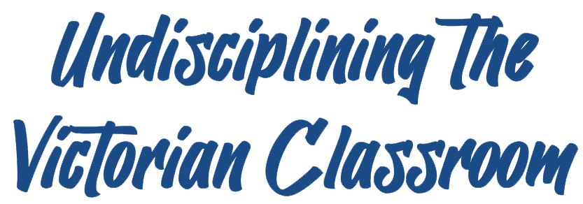
Peer-Reviewed Syllabus
Peer Reviewer: Mark Knight
Date: 2023
License: CC BY-NC 4.0

The Muslim “Other” in Nineteenth-Century British Literature

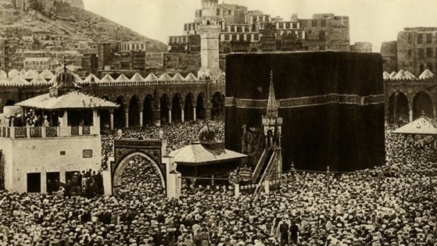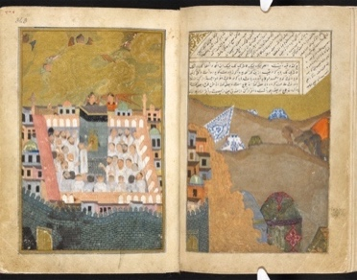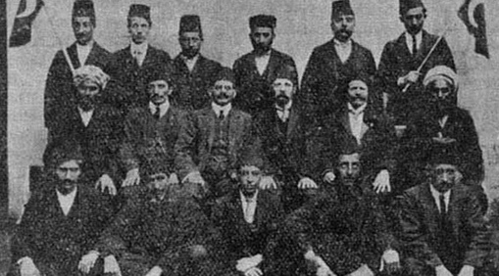
Fig. 1-3 (left to right): Picture of the Kaaba in Mecca taken in 1880 by Egyptian Mohammed Sadiq Bey (Alarabiya). A Timurid painting of Mecca, depicting the pilgrims camping outside and making preparations. Miscellany of Iskandar Sultan, 1410–11, manuscript, 18.4 x 12.7 cm (The British Library). Abdallah Quilliam Society, located in Liverpool; Quilliam is credited with converting 200 people in Liverpool and 600 people across the UK to Islam (BBC news).

Dana Aicha Shaaban | Texas Christian University | d.shaaban@tcu.edu

Course Description:
This course examines the complex intersection of Islam, race, and empire in British literature of the long nineteenth century. Students will be introduced to the religious and historical aspects of Islam, highlighting Victorian Britain’s common misconceptions about the Muslim world and its people. Shifting the focus from the imperial center, the course will introduce students to works by Arab and Muslim authors that have been translated to English. Moreover, using intersectional and postcolonial lenses, students will examine periodicals, travel literature, poetry, plays and novels that offer varying depictions of “British” identities compared to the Islamic and/or Oriental “Other.” These texts propagated, adapted, and interpreted information pertaining to the Middle East and presented contrasting images of Arabs and Muslims to the British public, shedding light on the complexity of the period’s popular views of foreign countries and transcultural relations. Students will also explore the literary representations of these Muslim “Others” by reading sections from The Arabian Nights, which greatly influenced nineteenth-century British authors as they crafted their stories, highlighting their belief in the superiority of British culture and identity. Assignments include discussion posts, discussion leading, an exam, a creative project and presentation, and a final seminar paper, as well as several collaborative activities.

Required Texts:

Purchase the following:
- The Arabian Nights (2008) edited by Muhsin Mahdi and translated by Husain Haddawy; ISBN-13: ‎978-0393331660 (Paperback edition)
- Salomé by Oscar Wilde (1891), found in The Plays of Oscar Wilde (2000); ISBN-13: 978-1840224184
- Desert Songs of the Night (2015) edited by Suheil Bushrui and James M. Malarkey; ISBN-13: 978-0863561757
The remaining texts will be available on our course website as PDF documents. Some of these texts are also available as free audiobooks at https://librivox.org/.

Periodicals: Fiction, non-fiction, and travel literature (1866-1877)
- “Three Egyptian Sketches” and “More Egyptian Sketches” by Mrs. N. M. O’Donnell (Aunt Judy’s Magazine)
- “The Overland Route to India” (Chatterbox)
- “The Progress of Geographical Discovery” by Fred Myron Colby (Our Young Folks Weekly Budget)

Poetry/Prose
- “Kubla Khan” (1816) by Samuel L. Coleridge
- “Recollection of the Arabian Nights” (1830) by Alfred Tennyson
- “The Prelude” (1850) by William Wordsworth
- “Sohrab and Rustum” (1853) by Matthew Arnold
- “Rubaiyat of Omar Khayyam” (1859) by Edward Fitzgerald
- “They’ve Dressed you in Blood upon Blood” (1901) by Hafiz Ibrahim (My translation into English)

Novels
- Sections from Cranford (1853) by Elizabeth Gaskell
- Sections from The Picture of Dorian Gray (1890) by Oscar Wilde
- Sections from Dombey and Son (1848) by Charles Dickens

Secondary Texts:
- Select chapters from ‘The Infidel Within’: Muslims in Britain since 1800 (2000) by Humayun Ansari
- Introduction from Orientalism (1978) by Edward Said
- Select chapters from Islam and the Victorians: Nineteenth Century Perceptions of Muslim Practices and Beliefs (2008) by Shahin Kuli Khan Khattak
- “Under the Spell of Magic: The Oriental Tale in Rimsky-Korsakov’s Sheherazade” by Nasser Al-Taee from The Arabian Nights in Historical Context: Between East and West by Saree Makdisi and Felicity Nussbaum
- “Islam, ‘A kind of Christianity’?” by Martin Pugh from Britain & Islam.
- TED talk by Kimberlé Crenshaw
- Video on Orientalism by Edward Said

Further Reading:
Berger, Maurits S. A Brief History of Islam in Europe: Thirteen Centuries of Creed, Conflict and Coexistence. Leiden University Press, 2015.
Gilham, Jamie. Loyal Enemies: British Converts to Islam, 1850-1950. Hurst & Company, 2014.
Issawi, Charles Philip. “Change in Western Perceptions of the Orient Since the Eighteenth Century.” Cross-Cultural Encounters and Conflicts. Oxford University Press, 2010, pp. 143-150.
Kabbani, Rana. Europe's Myths of Orient: Devise and Rule. Bloomington: Indiana University Press, 1986.
Motadel, David, editor. Islam and the European Empires. Oxford University Press, 2016.
Pugh, Martin. Britain & Islam. Yale University Press, 2019.

Assignments:
Threaded Discussions (15% total—5 at 3% each):
You will be asked to participate in a discussion forum related to the material you read for class. I will post questions to begin the discussion, but you should also consider this a conversation in which you discuss the readings with your fellow classmates. I will read the posts and occasionally post a question or clarification, but the discussion is primarily a space for your ideas. There are 5 Threaded Discussions scheduled for the term.

Each week, I expect you to participate in two distinct ways in the Threaded Discussion:
- An initial post that responds to a question I have posed in the prompt and includes an interpretive question that your peers can respond to (10 points)
- A reply to one of your classmates that directly responds to a(n) issue/question they have raised (5 points)

Word Journals (10% total—5 at 2% each):
This assignment is composed of two parts. First, you will summarize a short text we have read in a single word. Next, you will write a paragraph or two explaining why you chose that specific word to summarize the text.

Midterm Exam (15%):
This is a timed exam that will take the form of short answers, multiple choice, true or false, and one short essay question.

Cajitas Project (15%) and Oral Presentation (5%):
In this assignment, you will be asked to take on the persona (you will mentally put yourselves in the shoes and mindset) of one of the characters in the primary texts we are reading. After you choose this character, you will create a “little box” (cajita) with items that tell a story or reflect elements of the character’s past that have shaped their current identities (that you see in the novel). You will communicate/reflect on these objects by giving a short presentation (3-5 mins) describing each object in the box and how it has contributed to the character’s current identity that you see in the text.

Discussion Leading (15%):
You will be assigned to a group (3-4 people) who will be responsible for leading the class discussion for a portion of the class period (about 20-30 minutes) by exploring a topic or two in the text that interests you. To facilitate this discussion, please post three discussion questions in the designated online folder at least two days before your assigned day so your classmates can prepare potential answers (and to avoid awkward silences). Please be prepared to refer to specific passages in the text you wish to discuss. Each group member must have a specific task and lead the class discussion for at least 3-5 minutes.

Final Seminar Paper (25%):
For this final seminar paper, you will write an 8- to 10-page research paper on a topic of your choosing, which will challenge you to think more deeply about a particular issue related to Orientalism, Islam, and race in at least one primary text we have read in class. The paper must include at least 5 peer-reviewed sources (articles, book chapters, etc.) and be formatted in MLA style.

Course Schedule
This calendar represents my current plans and objectives. As we go through the semester, those plans may need to change to enhance class learning opportunities. Such changes will be clearly communicated.

Date | Readings | Assignments/Deadlines
 | Unit 1: Re-centering the Victorian “Other”
Week 1 | Historical Context
Day 1 | Introductions and Syllabus overview  Listen: “Sheherazade” musical piece by Rimsky Korsakov (in class)
Day 2 | Go over key terms, historical context, and Al-Nahda (Arab Renaissance)  Read: “Muslim Migration and Settlement in Britain before 1945” (in Ansari—pp. 27-44)

Week 2 | Arab and Muslim Voices
Day 1 | Read: Khalil Mutran’s “The Arab Awakening”  Read: Gibran Khalil Gibran’s “From a speech by Khalil the Heretic” | Discussion Leading Group 1
Day 2 | Read: Mikhail Naimi’s “Comrade!”  Read: Hafiz Ibrahim’s “They’ve Dressed you in Blood upon Blood” (my translation of the poem from Arabic to English) | Write: Threaded Discussion on poetry and prose from Arab or Muslim writers
Week 3 | Egypt, Lebanon, and The Arabian Nights
Day 1 | Read: “The Story of the Three Apples” from The Arabian Nights  Read: “Elegy to Mustafa Kamil” by Hafiz Ibrahim | Write: Word Journal  Note for UVC readers: Stories from The Arabian Nights are included in all three units as an underlying thread that runs through the syllabus because the text played an influential role in forming the stereotypes British people in the nineteenth century held about the different cultures and religions in the “East,” especially when it came to connecting Islam to the “Orient.”
Day 2 | Read: “Rejoice” by May Ziadeh  Read: “General Misconceptions” from Khattak’s Islam and the Victorians (pp. 108-116 and 130-134) | Discussion Leading Group 2
Week 4 | Arabian Poetry and Music Influenced by Shahrazad’s Story
Day 1 | Read: “An Andalusian Exile” by Ahmad Shawqi | Discussion Leading Group 3
Day 2 | Read: Al-Taee’s “Under the Spell of Magic” (pp. 265-295) | Write: Word Journal

 | Unit 2: British Childhood Reading (“West” meets “East”)
Week 5 | Victorian Children’s Periodicals
Day 1 | Read: “The British Victorians who became Muslims”  Read: Mrs. N. M. O’Donnell’s “Three Egyptian Sketches” and “More Egyptian Sketches” (Aunt Judy’s Magazine) | Note for UVC readers: In this unit, I have included easy-to-read articles such as “The British Victorians who became Muslims” and “Western Perceptions of Islam” to shed light on the fact that a group of British people, centered in Victorian Liverpool, converted to Islam at the time. Liverpool was “the gateway to the Empire and new world; it was a complex multicultural melting pot with permanent and shifting communities of foreigners, not least scores of Muslim sailors, traders, students, and travellers from across the world” (Gilham 88). Though they were not treated as badly as Muslims from other parts of the world, white British converts were marginalized for their religious beliefs and faced “collective religious discrimination” (Gilham 95).
Day 2 | Read: “Western Perceptions of Islam”  Read: “The Overland Route to India” (Chatterbox)  Read: “The Progress of Geographical Discovery” by Fred Myron Colby (Our Young Folks Weekly Budget) | Write: Threaded Discussion on stories in children’s periodicals and relate them to Victorian perceptions of Islam

Week 6 | Orientalism in “Western” Poetry
Day 1 | Read: “Introduction” from Said’s Orientalism (1-28)  Watch: Said’s video on Orientalism | Write: Word Journal
Day 2 | Read: “Kubla Khan” by Samuel L. Coleridge  Read: Sections from “The Prelude” by William Wordsworth
Week 7 | Midterm Exam and Fall Break
Day 1 |  | Write: Midterm Exam
Day 2 | Fall Break

Week 8 | The Arabian Nights and Stereotypes
Day 1 | Watch: Crenshaw’s TED talk on Intersectionality  Read: Frame tale from The Arabian Nights | Discussion Leading Group 4
Day 2 | “Recollection of the Arabian Nights” by Lord Alfred Tennyson
Week 9 | Conflating Islam and the “Oriental”
Day 1 | Read: Sections from Wilde’s The Picture of Dorian Gray and Gaskell’s Cranford | Write: Word Journal
Day 2 | Read: Sections from Wilde’s The Picture of Dorian Gray and Gaskell’s Cranford | Write: Threaded Discussion on The Picture of Dorian Gray and Cranford

 | Unit 3: Re-orienting Orientalism
Week 9 | The “Exotic East”
Day 1 | Read: “Literary Background” from Khattak’s Islam and the Victorians (pp. 44-74) | Note for UVC readers: In unit three, students delve deeper into the British fascination with these “Oriental Others” by exploring different genres of texts by canonical writers of the Victorian era like Charles Dickens, Oscar Wilde, Matthew Arnold, and Edward Fitzgerald. Focusing on representations, intertextual references, and writing style and themes, students will come to realize how indebted these canonical authors were to Middle Eastern and Asian religions and cultures at the time. Excerpts from Act I of Ahmad Shawqi’s Majnun Layla will be read alongside Wilde’s Salomé to juxtapose how the “Orient” and “Oriental” characters are depicted from different cultural perspectives.
Day 2 | Read: “Exoticism in 19th Century Literature”  Read: Sections from Dickens’s Dombey and Son | Discussion Leading Group 5
Week 10 | “Western” and “Eastern” Plays
Day 1 | Read: Wilde’s Salomé
Day 2 | Read: excerpt from Act I in Shawqi’s Majnun Layla | Write: Threaded Discussion on Salomé and Majnun Layla
Week 11 | Race, Gender, and Class in The Arabian Nights
Day 1 | Read: “The Story of the Porter and the Three Ladies” (from The Arabian Nights) | Write: Word Journal
Day 2 | Read: “The Story of the Merchant and the Demon” (from The Arabian Nights)
Week 12 | Western Poetry about the “East”
Day 1 | Read: Arnold’s “Sohrab and Rustum” | Discussion Leading Group 3
Day 2 | Read: Edward Fitzgerald’s “Rubaiyat of Omar Khayyam” | Write: Threaded Discussion on poetry
Week 13 | Cajitas Project
Day 1 | Time in class dedicated to working on and revising Cajitas Project before submission
Day 2 |  | Write and Present: Cajitas Project due
Week 14 | Thanksgiving Break
Week 15 | Wrap-up Week
Day 1 | Writing Day: Students work on their final papers in class and ask questions
Day 2 | Answer any remaining questions about final paper  Reflections on course and wrap up discussion
Week 16 | FINALS WEEK
 | Final papers due

