Peer-Reviewed Syllabus
Peer Reviewer: Charles LaPorte
Date: 2024
License: CC BY-NC 4.0

Constructing Religion and Empire in Nineteenth-Century Literature: Senior Capstone

Winter Jade Werner
werner_winter@wheatoncollege.edu

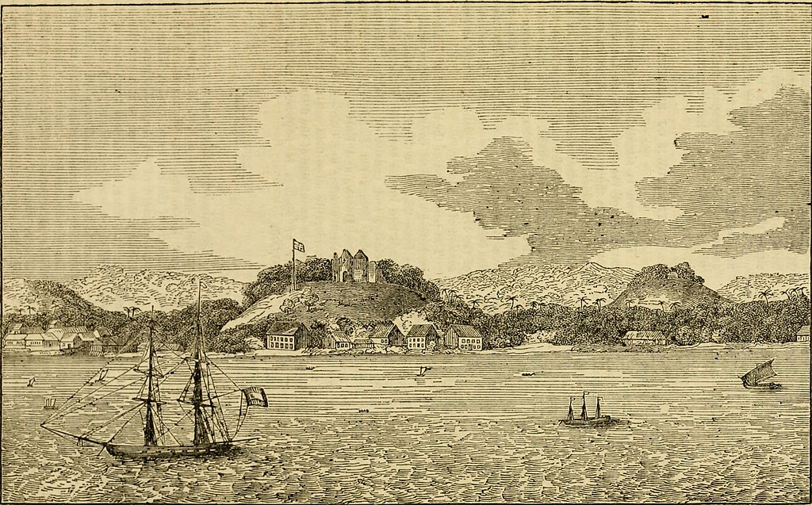

London Missionary Society. “Malacca” in 1831. Image from the Cover of Missionary Sketches No. LIV, July 1831. July 1831, https://en.m.wikipedia.org/wiki/File:Malacca_in_1831.jpg.

Course Description:
Can the literature of empire provide a critical history of “religion”? In this course, we consider how globalization and imperialism transformed, consolidated, and defined ideas of what constituted “religion” and “secularism” in the modern age, and how authors and religious thinkers of the global nineteenth century intervened in these debates. Reading a diverse set of texts from different locations—novels primarily, but also short stories, essays, sermons, and more—we will trouble the dualisms that tend to govern our thinking of religion and empire (religious versus secular, imperial versus indigenous, metropole versus colony, reason versus faith). Our aim throughout will be to (re)examine known and overlooked religious movements and moments—the secularization of “religion” in Orientalist scholarship; the impact of the missionary movement on colonial education and international print culture; the co-optation of Protestant discourse by Neo-Vedantic thinkers to “legitimate” Hinduism—to challenge the oft-presumed narrative that the modern era was marked by the ebbing of religion from public life. This capstone course instead suggests that imperialism reinvented and relocated the sites of religious belief and practice, and interrogates how nineteenth-century authors alternately critiqued, advanced, and amended these developments.

Assessment:
- Essay 1: 4 page analytic essay
- Essay 2: 3 page “museum exhibition” essay, paired project
- Essay 3: 10-12 page final essay

Museum Exhibition Essay
For this assessment essay, you will work in pairs to research and describe a nineteenth-century sermon or essay from a religious periodical for a public audience, as though you were writing for a museum catalogue. Writing in formal but accessible prose, use research to (1) introduce and describe the sermon or essay; (2) analyze its formal and rhetorical strategies (and, if relevant, its relationship to literary works read in the course thus far); and (3) argue for its significance and import in understanding how imperialism impacted religious thought/belief/practice, or vice versa.

Learning Outcomes:
By the end of this course, students will be able to:
- Articulate key ways that imperialism and multivarious expressions of religious faith and practice intersected in the nineteenth century.
- Identify how imperial writing contributes to constructing the categories of “religion,” “religions,” and “the secular,” and the ways these categories reinforced and/or undermined the civilizational and racial hierarchies established under imperialism.
- Analyze critically the relationship between diverse literary forms and religious imperialism and/or religious anticolonialism.
- Deploy a broad critical and theoretical vocabulary in relation to literary representations of religion and imperialism.
- Consider the extent that the historical entanglement of religion and imperialism may or may not explain the troubling resurgence of religious nationalisms today.

Course Texts:
- Sydney Owenson, The Missionary
- Charlotte Brontë, Jane Eyre
- Abdullah bin Abdul Kadir, The Hikayat Abdullah
- Toru Dutt, Bianca, Or, The Young Spanish Maiden
- Krupabai Satthianadhan, Saguna: A Story of Native Christian Life
- H. Rider Haggard, She
- Rudyard Kipling, Kim
- Paramahansa Yogananda, Autobiography of a Yogi (1946 edition)

Course Schedule:

- Introduction: “Religion” as Imperial Construct
Monday:
  - Jonathan Z. Smith, “Religion, Religions, Religious”
  - David Chidester, Empire of Religion (introduction)
Wednesday:
  - Tomoka Masuzawa, The Invention of World Religions (preface)
  - Edward Said, (excerpt from “Secular Criticism” [6 pages]; “Religious Criticism”)
  - Michael Allan, In the Shadow of World Literature (excerpt from ch. 1 [8 pages])

- Revisiting Orientalism, Race, and “Religion”
Monday:
  - Sydney Owenson, The Missionary
Wednesday:
  - Sydney Owenson, The Missionary
  - Aamir Mufti, “Orientalism and the Institution of World Literatures”

- Revisiting Orientalism, Race, and “Religion,” cont.
Monday:
  - Sydney Owenson, The Missionary
  - Maurice Olender, The Languages of Paradise: Race, Religion, and Philology in the Nineteenth Century (Preface)
Wednesday:
  - Charlotte Brontë, Jane Eyre

- Revisiting the Foreign Missionary Movement
Monday:
  - Charlotte Brontë, Jane Eyre (cont.)
Wednesday:
  - Charlotte Brontë, Jane Eyre (end)
  - Charlotte Brontë, “The Missionary”
  - Mary Ellis Gibson, “Henry Martyn and England’s Christian Empire: Rereading Jane Eyre Through Missionary Biography”

- Paper 1 Workshop Week
Monday:
  - Thesis Statement Workshop
Wednesday:
  - Peer Editing Workshop

Essay 1 Due this Week

- Religion, Malay Letters, and the Making of 19th-C. “World Literature”
Monday:
  - Abdullah bin Abdul Kadir, The Hikayat Abdullah (including “Introduction”)
  - Amin Sweeney, “A Man of Bananas and Thorns”
Wednesday:
  - Abdullah bin Abdul Kadir, The Hikayat Abdullah

- The Making of 19th-C. “World Literature,” cont.
Monday:
  - Abdullah bin Abdul Kadir, The Hikayat Abdullah
  - Michael Allan, In the Shadow of World Literature (excerpt from introduction [9 pages])
Wednesday:
  - Toru Dutt, Bianca, Or, The Young Spanish Maiden,
  - Mary Ellis Gibson, Indian Angles (ch. 5)

- Religion, Intertextuality, and Imperial Education
Monday:
  - Krupabai Satthianadhan, Saguna: A Story of Native Christian Life
  - Harish Trivedi, “Colonial Influence, Postcolonial Intertextuality: Western Literature and Indian Literature”
Wednesday:
  - Krupabai Satthianadhan, Saguna
  - Priya Joshi, In Another Country (ch. 5)

- Connective Religion, Cosmopolitanism, and Neo-Vedantic Hinduism
Monday:
  - Protap Chunder Mozoomdar, The Oriental Christ
Wednesday:
  - Keshub Chunder Sen, “Jesus Christ, Europe, and Asia”
  - J. Barton Scott, Spiritual Despots (introduction)

- Theosophy, Spiritualism, and Empire
Monday:
  - H. Rider Haggard, She
  - Helena Petrovna Blavatsky, Isis Unveiled (excerpt [21 pages])
  - Journal of the Society for Psychical Research (excerpts [18 pages])
Wednesday:
  - In-Class “Museum Exhibition” Work Day

- Theosophy, Spiritualism, and Empire, cont.
Monday:
  - H. Rider Haggard, She
  - Peer Editing Workshop
Wednesday:
  - H. Rider Haggard, She
  - Gauri Viswanathan, “‘Have Animals Souls?’: Theosophy and the Suffering Body”

Essay 2 Due this Week

- The Rise of the “Global Guru”
Monday:
  - Rudyard Kipling, Kim
Wednesday:
  - Rudyard Kipling, Kim
  - Srinivas Aravamudan, Guru English (excerpt from introduction [11 pages]; excerpt from chapter 2 [14 pages])

- The Rise of the “Global Guru,” cont.
Monday:
  - Rudyard Kipling, Kim
Wednesday:
  - Rudyard Kipling, Kim
  - Paramahansa Yogananda, Autobiography of a Yogi (excerpts)

- The Rise of the “Global Guru,” cont.
Monday:
  - Paramahansa Yogananda, Autobiography of a Yogi (ch. 1-24)
  - David Neumann, Finding God Through Yoga: Paramahansa Yogananda and Modern American Religion in a Global Age (introduction)
Wednesday:
- Class Reflection & Free-Writing Session

- Final Essay Workshop
Monday:
  - Thesis Statement Workshop
Wednesday:
  - Introduction and Two Body Paragraphs Workshop

- Final Essays Due

Essay 3 Due this Week

